

oneM2M
Technical Specification
Document Number | TS-0008- V-3.0.0
Document Name: | CoAP Protocol Binding
Date: | 2018-02-27
Abstract: | The specification will cover the protocol specific part of communication protocol used by oneM2M compliant systems as 'CoAP binding'

This Specification is provided for future development work within oneM2M only. The Partners accept no liability for any use of this Specification.
The present document has not been subject to any approval process by the oneM2M Partners Type 1. Published oneM2M specifications and reports for implementation should be obtained via the oneM2M Partners' Publications Offices.

About oneM2M
The purpose and goal of oneM2M is to develop technical specifications which address the need for a common M2M Service Layer that can be readily embedded within various hardware and software, and relied upon to connect the myriad of devices in the field with M2M application servers worldwide.
More information about oneM2M may be found at: http//www.oneM2M.org
Copyright Notification
No part of this document may be reproduced, in an electronic retrieval system or otherwise, except as authorized by written permission.
The copyright and the foregoing restriction extend to reproduction in all media.
© 2016, oneM2M Partners Type 1 (ARIB, ATIS, CCSA, ETSI, TIA, TSDSI, TTA, TTC).
All rights reserved.
Notice of Disclaimer & Limitation of Liability
The information provided in this document is directed solely to professionals who have the appropriate degree of experience to understand and interpret its contents in accordance with generally accepted engineering or other professional standards and applicable regulations. No recommendation as to products or vendors is made or should be implied.
NO REPRESENTATION OR WARRANTY IS MADE THAT THE INFORMATION IS TECHNICALLY ACCURATE OR SUFFICIENT OR CONFORMS TO ANY STATUTE, GOVERNMENTAL RULE OR REGULATION, AND FURTHER, NO REPRESENTATION OR WARRANTY IS MADE OF MERCHANTABILITY OR FITNESS FOR ANY PARTICULAR PURPOSE OR AGAINST INFRINGEMENT OF INTELLECTUAL PROPERTY RIGHTS. NO oneM2M PARTNER TYPE 1 SHALL BE LIABLE, BEYOND THE AMOUNT OF ANY SUM RECEIVED IN PAYMENT BY THAT PARTNER FOR THIS DOCUMENT, WITH RESPECT TO ANY CLAIM, AND IN NO EVENT SHALL oneM2M BE LIABLE FOR LOST PROFITS OR OTHER INCIDENTAL OR CONSEQUENTIAL DAMAGES. oneM2M EXPRESSLY ADVISES ANY AND ALL USE OF OR RELIANCE UPON THIS INFORMATION PROVIDED IN THIS DOCUMENT IS AT THE RISK OF THE USER.
Contents
1 Scope 5
2 References 5
2.1 Normative references 5
2.2 Informative references 5
3 Abbreviations and acronyms 5
4 Conventions 6
5 Overview 6
5.0 Introduction 6
5.1 Required Features 6
5.2 Introduction of CoAP 6
5.2.0 Introduction 6
5.2.1 Message Format 7
5.2.2 Caching 7
5.2.2.0 Introduction 7
5.2.2.1 Freshness 7
5.2.2.2 Validity 7
5.2.3 Blockwise Transfers 7
6 CoAP Message Mapping 8
6.1 Introduction 8
6.2 Primitive Mapping to CoAP Message 8
6.2.0 Introduction 8
6.2.1 Header 8
6.2.2 Configuration of Token and Options 9
6.2.2.0 Introduction 9
6.2.2.1 Token 9
6.2.2.2 Content Format Negotiation Options 9
6.2.2.3 URI Options 10
6.2.2.4 Definition of New Options 10
6.2.2.4.0 Introduction 10
6.2.2.4.1 From 11
6.2.2.4.2 Request Identifier 11
6.2.2.4.3 Void 11
6.2.2.4.4 Originating Timestamp 11
6.2.2.4.5 Request Expiration Timestamp 11
6.2.2.4.6 Result Expiration Timestamp 11
6.2.2.4.7 Operation Execution Time 11
6.2.2.4.8 notificationURI of Response Type 11
6.2.2.4.9 Event Category 11
6.2.2.4.10 Response Status Code 12
6.2.2.4.11 Group Request Identifier 12
6.2.2.4.12 Resource Type 12
6.2.2.4.13 Content Offset 12
6.2.2.4.14 Content Status 12
6.2.2.4.15 Assigned Token Identifiers 12
6.2.2.4.16 Release Version Indicator 12
6.2.2.4.17 Vendor Information 12
6.2.3 Payload 12
6.2.4 Response Codes Mapping 14
6.3 Accessing Resources in CSEs 15
6.3.0 Introduction 15
6.3.1 Blocking case 15
6.3.2 Non-Blocking Asynchronous case 16
6.3.3 Non-Blocking Synchronous case 16
6.4 Mapping rules of caching 16
6.5 Usage of Blockwise Transfers 16
7 Security Consideration 17
Annex A (informative): Example Procedures 18
A.1 Blocking case of AE Registration 18
A.2 Non-blocking synchronous case of AE Registration 18
History 20

1 Scope
The present document will cover the protocol specific part of communication protocol used by oneM2M compliant systems as 'RESTful CoAP binding'.
The scope of the present document is (not limited to as shown below):
- Binding oneM2M primitives to CoAP messages.
- Binding oneM2M Response Status Codes to CoAP Response Codes.
- Defining behaviour of a CoAP Client and Server depending on oneM2M parameters.

2 References

2.1 Normative references
References are either specific (identified by date of publication and/or edition number or version number) or non-specific. For specific references, only the cited version applies. For non-specific references, the latest version of the referenced document (including any amendments) applies.
The following referenced documents are necessary for the application of the present document.
[1] IETF RFC 7252: "The Constrained Application Protocol (CoAP)".
[2] oneM2M TS-0004: " Service Layer Core Protocol Specification".
[3] IETF RFC 7959: "Block-Wise Transfers in the Constrained Application Protocol (CoAP)".
[4] oneM2M TS-0003: "Security solutions".
[5] IETF RFC 6347: "Datagram Transport Layer Security Version 1.2".

2.2 Informative references
References are either specific (identified by date of publication and/or edition number or version number) or non-specific. For specific references, only the cited version applies. For non-specific references, the latest version of the reference document (including any amendments) applies.
The following referenced documents are not necessary for the application of the present document but they assist the user with regard to a particular subject area.
[i.1] oneM2M Drafting Rules.
NOTE: Available http://www.onem2m.org/images/files/oneM2M-Drafting-Rules.pdf.

3 Abbreviations and acronyms
For the purposes of the present document, the following abbreviations and acronyms apply:
ACK Acknowledgement
AE Application Entity
CON Confirmable
CSE Common Service Entity
DTLS Datagram Transport Layer Security
HTTP Hyper Text Transfer Protocol
IANA Internet Assigned Numbers Authority
IP Internet Protocol
RST CoAP Reset message
TCP Transport Control Protocol
TLS Transport Layer Security
TLV Tag - Length - Value (data structure)
UDP User Datagram Protocol
URI Uniform Resource Identifier
XML eXtensible Markup Language

4 Conventions
The keywords "Shall", "Shall not", "May", "Need not", "Should", "Should not" in the present document are to be interpreted as described in the oneM2M Drafting Rules [i.1].

5 Overview

5.0 Introduction
The clause describes which features need to be supported in CoAP layer and introduces a message format and several features of CoAP used in this procotol binding specification.

5.1 Required Features
This clause explicitely specifies the required features of the CoAP layer for oneM2M to properly bind oneM2M primitives into CoAP messages:
- The 4-byte binary CoAP message header is defined in section 3 of [1].
- Confirmable (CON), Acknowledgement (ACK) and Reset (RST) messages shall be supported. The Reset message is used to send a error message in response to a malformed Confirmable message in CoAP layer.
- GET, PUT, POST and DELETE methods shall be supported. oneM2M primitives map to these methods.
- A subset of Response Code specified in clause 6.2.4 shall be supported for oneM2M Response Status Code parameter mapping.
- The Uri-Host, Uri-Port, Uri-Path, and Uri-Query shall be supported.
- The Content-Type Option shall be used to indicate the media types of the payload.
- The Token Option may be used.
- Block-wise transfers feature may be supported to carry large payloads.
- Caching feature may be supported.

5.2 Introduction of CoAP

5.2.0 Introduction
This clause describes a message format, and caching and block-wise transfers features which may be used to map oneM2M primitives to CoAP messages.

5.2.1 Message Format
This clause specifies details about the CoAP [1] message format:
- CoAP message occupies the data section of one UDP datagram.
- CoAP message format supports a 4-byte fixed-size header.
- Fixed-size header is followed by a Token value of length 0 to 8 bytes.
- The Token value is followed by a sequence of zero or more CoAP Options in TLV format.
- CoAP Options are followed by the payload part.
For more details on the CoAP message format and the supported header fields, refer [1].

5.2.2 Caching

5.2.2.0 Introduction
CoAP [1] supports caching of responses to fulfill future equivalent requests to the same resource. Caching is supported using freshness and validity information carried with CoAP [1] responses.

5.2.2.1 Freshness
- CoAP server shall use Max-Age CoAP Option to specify the explicit expiration time for the CoAP Response's resource representation. This indicates that the response is not fresh after its age is greater than the specified number of seconds.
- Max-Age Option defaults to a value of 60 (seconds). In case, Max-Age Option is not present in the cacheable response, the response shall not be considered fresh after its age is greater than 60 seconds.
- The CoAP server shall set the Max-Age Option value to 0 (zero) to prevent or disable caching.
- The CoAP client, having a fresh stored response, can make new request matching the request for that stored response. In this case, the new response shall invalidate the old response.

5.2.2.2 Validity
- A CoAP endpoint with stored responses but not able to satisfy subsequent requests (for example, the response is not fresh), shall use the Etag Option to perform a conditional request to the CoAP server where the resource is hosted.
- If the cached response with the CoAP client is still valid, the server shall include the Max-Age Option in the response along with a code of 2.03 - Valid. This shall update the freshness of the cached response at the CoAP client.
- If the cached response with the CoAP client is not valid, the server shall respond with an updated representation of the resource with response code 2.05 - Content. The CoAP client shall use the updated response to satisfy request and may also replace/update the stored or cached response.

5.2.3 Blockwise Transfers
CoAP Block [3] Options may be used when CoAP endpoints need to transfer large payloads e.g. firmware, software updates. Instead of relying on IP fragmentation, CoAP Block Option should be used for transferring multiple blocks of information in multiple request-response pairs.

6 CoAP Message Mapping

6.1 Introduction
When AE or CSE binds oneM2M primitives to CoAP messages, or binds CoAP messages to oneM2M primitives, it is required that:
- AE shall host a CoAP client and should host a CoAP server; or
- CSE shall host both a CoAP client and a CoAP server.
Basically single oneM2M request primitive is mapped to single CoAP request message, and single oneM2M response primitive is mapped to single CoAP response message. However, single oneM2M request/response primitive is mapped to multiple CoAP request/response messages respectively when CoAP block-wise transfers feature is used.
Mapping between CoAP message and oneM2M primitive shall be applied in the following cases:
- when the Originator sends a request primitive;
- when the Receiver receives a CoAP message(s);
- when the Receiver sends a response primitive;
- when the Originator receives a CoAP message(s).
The following sub-clauses specify how to map each oneM2M primitive parameter defined in [2] to a corresponding CoAP message field to compose a CoAP request/response message.

6.2 Primitive Mapping to CoAP Message

6.2.0 Introduction
This clause describes where to map oneM2M parameters in a primitive to header, Option and payload fields in a CoAP message.

6.2.1 Header
This clause specifies how to configure CoAP header information:
- The Version field shall be configured as 1.
- The Type field shall be configured according to clause 6.3. The Reset message is used to send a error message in response to a malformed Confirmable message in CoAP layer.
- In case of a request, the Code field indicates CoAP Method. The oneM2M Operation parameter shall be mapped to a CoAP Method according to the table 6.2.1-1.
- In case of a response, the Code field indicates CoAP Response Code. The oneM2M Response Status Code parameter shall be mapped to CoAP Response Code as specified in clause 6.2.4.
The configurations of Token Length and Message ID are left to implementation.
Table 6.2.1-1: oneM2M Operation Parameter Mapping
oneM2M Operation Parameter | CoAP Method
CREATE | POST
RETRIEVE | GET
UPDATE | PUT
DELETE | DELETE
NOTIFY | POST

At the Receiver, CoAP request message with POST method shall be mapped to oneM2M CREATE or NOTIFY Operation parameter in accordance with the existence of Resource Type parameter. If Resource Type parameter exists then value of the Operation parameter is CREATE and if Resource Type parameter doesn't exist, the value of Operation parameter is NOTIFY.

6.2.2 Configuration of Token and Options

6.2.2.0 Introduction
This clause describes configuration of Token and Options based on oneM2M parameters.

6.2.2.1 Token
Due to size limitation, Request Identifier is not mapped to Token option. However, Token may be used in CoAP layer to match a CoAP request and response.

6.2.2.2 Content Format Negotiation Options
The CoAP Accept Option may be used to indicate which Content-Format is acceptable to an Originator. If a Hosting CSE supports the Content-Format specified in Accept Option of the request, the Hosting CSE shall respond with that Content-Format. If the Hosting CSE doesn't support the Content-Format specified in Accept Option of the request, 4.06 "Not Acceptable" shall be sent as a response, unless another error code takes precedence for this response.
Possible values for Content-Format and Accept options are listed below:
- application/xml (41);
- application/json (50);
- application/cbor (60);
- media types specified in clause 6.7 "oneM2M specific MIME media types" of [2].
Numeric values for oneM2M defined media types are listed in table 6.2.2.2-1.
Table 6.2.2.2-1: CoAP oneM2M Specific Content-Formats
oneM2M Specific Media Type | ID
vnd.onem2m-res+xml | 10014
vnd.onem2m-res+json | 10001
vnd.onem2m-ntfy+xml | 10002
vnd.onem2m-ntfy+json | 10003
vnd.onem2m-preq+xml | 10006
vnd.onem2m-preq+json | 10007
vnd.onem2m-prsp+xml | 10008
vnd.onem2m-prsp+json | 10009
vnd.onem2m-res+cbor | 10010
vnd.onem2m-ntfy+cbor | 10011
vnd.onem2m-preq+cbor | 10012
vnd.onem2m-prsp+cbor | 10013

NOTE: ID values for oneM2M specific media type are subject to change after IANA registration.

6.2.2.3 URI Options
This clause describes how to configure CoAP Uri-Host, Uri-Port, Uri-Path, and Uri-Query Options.
Host and port part of the address specified in pointOfAccess attribute of <remoteCSE> resource shall be mapped to Uri-Host and Uri-Port respectively.
If To parameter contains absolute format, then the first URI-Path Option shall contain a letter "_" and map To parameter removing starting "//" into next URI-Path Option(s).
If To parameter contains SP-relative format, then the first URI-Path Option shall contain a letter "~" and map To parameter removing starting "/" into next URI-Path Option(s).
If To parameter contains CSE-relative format, then To parameter shall be mapped to URI-Path Option(s).
Table 6.2.2.3-1 shows valid mappings between the To request primitive parameter and the Uri-Path of the CoAP.
CSEBase represents the resource name of a <CSEBase> resource, CSEBase/ae12/cont27/contInst696 represents a
structured CSE-relative resource ID, and cin00856 an unstructured CSE-relative resource ID.
Table 6.2.2.3-1: Mapping examples between To parameter and Uri-Path of the CoAP
Method |  | Request Scope
 |  | CSE-Relative | SP-Relative | Absolute
Structured | To | CSEBase/ae12/cont27/contInst696 | /CSE178/CSEBase/ae12/cont27/contInst696 | //mym2msp.org/CSE178/CSEBase/ae12/cont27/contInst696
Structured | Uri-Path | CSEBase |  | _
Structured | Uri-Path | CSEBase | ~ | mym2msp.org
Structured | Uri-Path | CSEBase | CSE178 | CSE178
Structured | Uri-Path | CSEBase | CSEBase | CSEBase
Structured | Uri-Path | ae12 | ae12 | ae12
Structured | Uri-Path | cont27 | cont27 | cont27
Structured | Uri-Path | contInst696 | contInst696 | contInst696
Unstructured | To | cin00856 | /CSE178/cin00856 | //mym2msp.org/CSE178/cin00856
Unstructured | Uri-Path | cin00856 |  | _
Unstructured | Uri-Path | cin00856 | ~ | mym2msp.org
Unstructured | Uri-Path | cin00856 | CSE178 | CSE178
Unstructured | Uri-Path | cin00856 | cin00856 | cin00856
NOTE: How to read this table : To primitive - from left to right, Uri-Path - from top to bottom.

The responseTypeValue element of Response Type, Result Persistence, Delivery Aggregation, Result Content, parameters of Filter Criteria, Discovery Result Type, Token Request Indicator, Tokens, Token IDs and Local Token IDs parameters shall be carried in Uri-Query Option in a short name form as specified in clause 8.2.2 [2].

6.2.2.4 Definition of New Options

6.2.2.4.0 Introduction
This clause describes new CoAP Options used for binding several oneM2M request/response parameters. Table 6.2.2.4.0-1 contains definitions of the new CoAP Options and sub-clauses specify oneM2M parameter mapping with the newly defined CoAP Options in the table 6.2.2.4.0-1.
Table 6.2.2.4.0-1: Definition of New Options
No | C | U | N | R | Name | Format | Length | Default
256 |  |  |  |  | oneM2M-FR | string | 0-255 | (None)
257 |  |  |  |  | oneM2M-RQI | string | 0-255 | (None)
259 |  |  |  |  | oneM2M-OT | string | 15 | (None)
260 |  |  |  |  | oneM2M-RQET | string | 15 | (None)
261 |  |  |  |  | oneM2M-RSET | string | 15 | (None)
262 |  |  |  |  | oneM2M-OET | string | 15 | (None)
263 |  |  |  |  | oneM2M-RTURI | string | 0-255 | (None)
264 |  |  |  |  | oneM2M-EC | uint | 1 | (None)
265 |  |  |  |  | oneM2M-RSC | uint | 2 | (None)
266 |  |  |  |  | oneM2M-GID | string | 0-255 | (None)
267 |  |  |  |  | oneM2M-TY | uint | 2 | (None)
268 |  |  |  |  | oneM2M-CTO | uint | 2 | (None)
269 |  |  |  |  | oneM2M-CTS | uint | 2 | (None)
270 |  |  |  |  | oneM2M-ATI | string | 0-255 | (None)
271 |  |  |  |  | oneM2M-RVI | string | 1 | (None)
272 |  |  |  |  | oneM2M-VSI | string | 0-255 | (None)
NOTE 1: C, U, N, R means Critical, Unsafe, NoCacheKey and Repeatable respectively [1]. Table 6.2.2.4.0-1 follows the template used in clause 5.10 Option Definitions of CoAP specification [1].
NOTE 2: CoAP Option numbers specified in table 6.2.2.4.0-1 are subject to change after review by IANA registration.

6.2.2.4.1 From
The From parameter shall be mapped to the oneM2M-FR Option.

6.2.2.4.2 Request Identifier
The Request Identifier parameter shall be mapped to the oneM2M-RQI Option.

6.2.2.4.3 Void

6.2.2.4.4 Originating Timestamp
The Originating Timestamp parameter shall be mapped to the oneM2M-OT Option.

6.2.2.4.5 Request Expiration Timestamp
The Request Expiration Timestamp parameter shall be mapped to the oneM2M-RQET Option.

6.2.2.4.6 Result Expiration Timestamp
The Request Expiration Timestamp parameter shall be mapped to the oneM2M-RSET Option.

6.2.2.4.7 Operation Execution Time
The Operation Execution Time parameter shall be mapped to the oneM2M-OET Option.

6.2.2.4.8 notificationURI of Response Type
The notificationURI element of Response Type parameter shall be mapped to the oneM2M-RTURI Option.

6.2.2.4.9 Event Category
The Event Category parameter shall be mapped to the oneM2M-EC Option.

6.2.2.4.10 Response Status Code
The Response Status Code parameter shall be mapped to the oneM2M-RSC Option.

6.2.2.4.11 Group Request Identifier
The Group Request Identifier parameter shall be mapped to the oneM2M-GID Option.

6.2.2.4.12 Resource Type
The Resource Type parameter shall be mapped to the oneM2M-TY Option.

6.2.2.4.13 Content Offset
The Content Offset parameter shall be mapped to the oneM2M-CTO Option.

6.2.2.4.14 Content Status
The Content Status parameter shall be mapped to the oneM2M-CTS Option.

6.2.2.4.15 Assigned Token Identifiers
The Assigned Token Identifiers parameter shall be mapped to the oneM2M-ATI Option. The format of the oneM2M-ATI option shall be represented as a sequence of lti-value:tkid-value pairs separated by a colon ':' and multiple pairs appended with '+' character.
EXAMPLE: The header looks as follows:
oneM2M-ATI: lti-value1:tkid-value1 + lti-value2:tkid-value2 + …
if the XML representation of the Assigned Token Identifiers parameter is given as (using short element names):
<ati>
<ltia>
<lti>lti-value1</lti>
<tkid>tkid-value1</tkid>
</ltia>
<ltia>
<lti>lti-value2</lti>
<tkid>tkid-value2</tkid>
</ltia>
…
</ati>
The data type m2m:dynAuthlocalTokenIdAssignments of the Assigned Token Identifiers parameter is defined in clause 6.3.5.43 of oneM2M TS-0004 [2].

6.2.2.4.16 Release Version Indicator
The Release Version Indicator parameter shall be mapped to the oneM2M-RVI Option.

6.2.2.4.17 Vendor Information
The Vendor Information parameter shall be mapped to the oneM2M-VSI Option.

6.2.3 Payload
Content parameter shall be mapped to CoAP payload. Blockwise transfers mechanism may be used to deliver large size of Content parameter which is not fit into one CoAP message. Please refer to clause 6.5 for the detail information. If Content parameter contains URI and resource representation in a response to a create request, URI shall be mapped to Location-Path Option.
A Token Request Information parameter included in a response primitive shall be mapped into the payload. The Content-Format shall be set compliant with the data representation

6.2.4 Response Codes Mapping
Table 6.2.4-1 defines a mapping between oneM2M Response Status Code parameter specified in [2] and CoAP Response Code.
In case of where multiple oneM2M Response Status Code parameters are mapped to single CoAP Status Code, Response Status Code parameter shall be specified in oneM2M-RSC Option.
Table 6.2.4-1 Mapping between oneM2M Response Status Code and CoAP Response Code
oneM2M Response Status Code | Description | Status Code of CoAP | Description
1000 | ACCEPTED | None | Empty Acknowledgement Message shall be used
2000 | OK | 2.05 | Content
2001 | CREATED | 2.01 | Created
2002 | DELETED | 2.02 | Deleted
2004 | UPDATED | 2.04 | Changed
4000 | BAD_REQUEST | 4.00 | Bad Request
4001 | RELEASE_VERSION_NOT_SUPPORTED | 4.00 | Bad Request
4004 | NOT_FOUND | 4.04 | Not Found
4005 | OPERATION_NOT_ALLOWED | 4.05 | Method Not Allowed
4008 | REQUEST_TIMEOUT | 4.04 | Not Found
4101 | SUBSCRIPTION_CREATOR_HAS_NO_PRIVILEGE | 4.03 | Forbidden
4102 | CONTENTS_UNACCEPTABLE | 4.00 | Bad Request
4103 | ORIGINATOR_HAS_NO_PRIVILEGE | 4.03 | Forbidden
4104 | GROUP_REQUEST_IDENTIFIER_EXISTS | 4.00 | Bad Request
4105 | CONFLICT | 4.03 | Forbidden
4106 | ORIGINATOR_HAS_NOT_REGISTERED | 4.03 | Forbidden
4107 | SECURITY_ASSOCIATION_REQUIRED | 4.03 | Forbidden
4108 | INVALID_CHILD_RESOURCE_TYPE | 4.03 | Forbidden
4109 | NO_MEMBERS | 4.03 | Forbidden
4110 | GROUP_MEMBER_TYPE_INCONSISTENT | 4.00 | Bad Request
4111 | ESPRIM_UNSUPPORTED_OPTION | 4.03 | Forbidden
4112 | ESPRIM_UNKNOWN_KEY_ID | 4.03 | Forbidden
4113 | ESPRIM_UNKNOWN_ORIG_RAND_ID | 4.03 | Forbidden
4114 | ESPRIM_UNKNOWN_RECV_RAND_ID | 4.03 | Forbidden
4115 | ESPRIM_BAD_MAC | 4.03 | Forbidden
4116 | ESPRIM_IMPERSONATION_ERROR | 4.03 | Forbidden
4117 | ORIGINATOR_HAS_ALREADY_REGISTERED | 4.03 | Forbidden
5000 | INTERNAL_SERVER_ERROR | 5.00 | Internal Server Error
5001 | NOT_IMPLEMENTED | 5.01 | Not Implemented
5103 | TARGET_NOT_REACHABLE | 4.04 | Not Found
5105 | RECEIVER_HAS_NO_PRIVILEGE | 4.03 | Forbidden
5106 | ALREADY_EXISTS | 4.00 | Bad Request
5203 | TARGET_NOT_ SUBSCRIBABLE | 4.03 | Forbidden
5204 | SUBSCRIPTION_VERIFICATION_INITIATION_FAILED | 5.00 | Internal Server Error
5205 | SUBSCRIPTION_HOST_HAS_NO_PRIVILEGE | 4.03 | Forbidden
5206 | NON_BLOCKING_REQUEST_NOT_SUPPORTED | 5.01 | Not Implemented
5207 | NOT_ACCEPTABLE | 4.06 | Not Acceptable
5208 | DISCOVERY_DENIED_BY_IPE | 4.03 | Forbidden
5209 | GROUP_MEMBERS_NOT_RESPONDED | 5.00 | Internal Server Error
5210 | ESPRIM_DECRYPTION_ERROR | 5.00 | Internal Server Error
5211 | ESPRIM_ENCRYPTION_ERROR | 5.00 | Internal Server Error
5212 | SPARQL_UPDATE_ERROR | 5.00 | Internal Server Error
5214 | TARGET_HAS_NO_SESSION_CAPABILITY | 4.03 | Forbidden
5215 | SESSION_IS_ONLINE | 4.03 | Forbidden
5216 | JOIN_MULTICAST_GROUP_FAILED | 5.00 | Internal Server Error
5217 | LEAVE_MULTICAST_GROUP_FAILED | 5.00 | Internal Server Error
6003 | EXTENAL_OBJECT_NOT_REACHABLE | 4.04 | Not Found
6005 | EXTENAL_OBJECT_NOT_FOUND | 4.04 | Not Found
6010 | MAX_NUMBERF_OF_MEMBER_EXCEEDED | 4.00 | Bad Request
6020 | MGMT_SESSION_CANNOT_BE_ESTABLISHED | 5.00 | Internal Server Error
6021 | MGMT_SESSION_ESTABLISHMENT _TIMEOUT | 5.00 | Internal Server Error
6022 | INVALID_CMDTYPE | 4.00 | Bad Request
6023 | INVALID_ARGUMENTS | 4.00 | Bad Request
6024 | INSUFFICIENT_ARGUMENTS | 4.00 | Bad Request
6025 | MGMT_CONVERSION_ERROR | 5.00 | Internal Server Error
6026 | MGMT_CANCELATION_FAILED | 5.00 | Internal Server Error
6028 | ALREADY_COMPLETE | 4.00 | Bad Request
6029 | MGMT_COMMAND_NOT_CANCELLABLE | 4.00 | Bad Request

The Receiver decides the Response Status Code parameter using the combination of CoAP Response Code and oneM2M-RSC Option information.

6.3 Accessing Resources in CSEs

6.3.0 Introduction
This clause describes the behavior of CoAP layer depending on Response Type parameter. Figure 6.3.0-1 illustrates the steps involved in each cases of interaction.
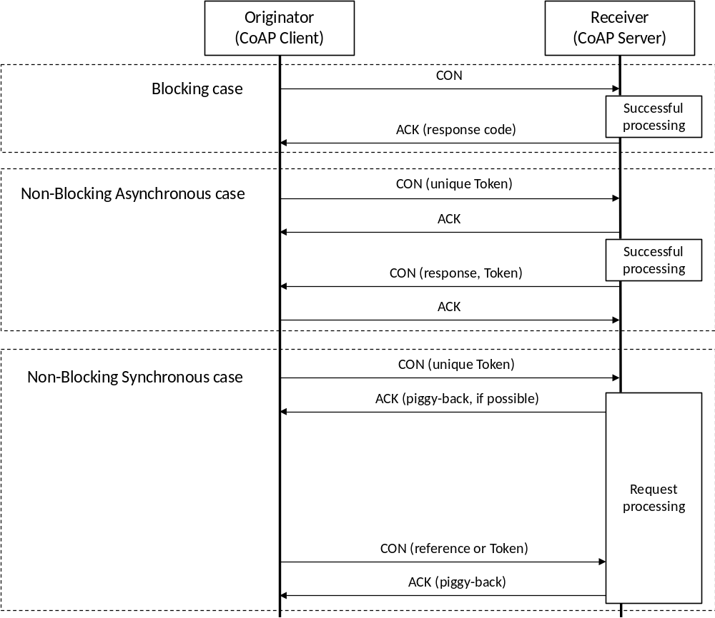
Figure 6.3.0-1: Accessing resource cases

6.3.1 Blocking case
- If Response Type parameter is configured as "blockingRequest" (blocking case), the Originator (CoAP client) shall use the Confirmable Method for the resource to the Receiver (CoAP server).
- In case of successful processing of the request at the Receiver, the Receiver shall piggyback the response with an appropriate response code in the Acknowledgment message that acknowledges the Confirmable request.

6.3.2 Non-Blocking Asynchronous case
- If Response Type parameter is configured as "nonBlockingRequestAsynch" (non-blocking asynchronous case), the Originator (CoAP client) shall use the Confirmable Method for the resource to the Receiver (CoAP server). Originator shall provide a unique Token value in the request.
- The Receiver shall provide an acknowledgment of receipt of the request using Acknowledgment message.
- The Receiver, upon successful processing of the request, shall send an appropriate response in a separate Confirmable message with the Token value. The Originator shall acknowledge the Confirmable response.

6.3.3 Non-Blocking Synchronous case
- If Response Type parameter is configured as "nonBlockingRequestSynch" (non-blocking synchronous case), the Originator (CoAP client) shall use the Confirmable Method for the resource to the Receiver (CoAP server). Originator shall provide a unique Token value in the request.
- The Receiver shall provide an acknowledgment of receipt of the request using Acknowledgment message. The response on the request may be piggy-backed in the Acknowledgement message if possible for the Receiver.
- The Receiver, after validating the request and before processing it fully, shall send an appropriate response including a reference in a separate Confirmable message. The Originator shall acknowledge the Confirmable response.
- The Originator can use the reference or the token to synchronously access or retrieve the resource. The Receiver, upon receipt of the request, shall respond with the current state of the resource.
NOTE: If the Receiver is a Transit CSE, the Receiver acts as CoAP client and CoAP server.

6.4 Mapping rules of caching
This clause specifies how to enable or disable CoAP caching mechanism and how to use cached information.
If the CoAP end point supports caching mechanism by freshness, the CoAP server shall:
- set the Max-Age Option value to "0" (zero) to disable caching, in order to support complete oneM2M mapping; or
- set the Max-Age option value to another value (such as the default value), in order to use CoAP caching mechanism for constrained environment.
NOTE 1: In the second case, the new request from oneM2M layer can get the stored fresh response from CoAP client, not from CoAP server.
If the CoAP end point supports caching mechanism by validity:
- the CoAP server shall not present Etag in responses to disable caching, in order to support complete oneM2M mapping; or
- the CoAP server shall present Etag in responses, in order to use CoAP caching mechanism for constrained environment.
NOTE 2: In the second case, the new request from oneM2M layer can get the stored fresh response from CoAP server, not from oneM2M layer.

6.5 Usage of Blockwise Transfers
Using Block Options, large oneM2M resource representations can be fragmented and reassembled by CoAP independently of the lower layers as well as the above application. The CoAP Block1 Option shall be used to define the size of the blocks used for oneM2M request primitives and the CoAP Block2 Option shall be used to define the size of the blocks used for oneM2M response responses. Refer [3] for further details.

7 Security Consideration
CoAP itself does not provide protocol primitives for authentication or authorization; where this is required, it shall be provided by DTLS.
Just as HTTP is secured using Transport Layer Security (TLS) over TCP, CoAP shall be secured using Datagram TLS (DTLS) [5].
All CoAP messages shall be sent as DTLS "application data". For matching an ACK or RST to a CON message or a RST to a NON message: The DTLS session shall be the same and the epoch shall be the same.
For matching a response to a request, the DTLS session shall be the same and the epoch shall be the same. The response to a DTLS secured request shall always be DTLS secured using the same security session and epoch.
OneM2M primitive parameters contained in CoAP messages may be protected by DTLS in a hop-by-hop manner. For the details, see oneM2M security solution specification [4].
NOTE: Some provisioning schemes of oneM2M TS-0003 [4] enable the provisioning of end-to-end credentials, but protocols to establish security associations between non-adjacent nodes are not addressed.by oneM2M in the present release.

Annex A (informative):
Example Procedures

A.1 Blocking case of AE Registration
Figure A.1-1 illustrates CoAP mapping of AE Registration procedure described in clauses 7.2.2.1, 7.4.6.2.2 and E.1 of oneM2M TS-0004 [2] and shows an example of blocking case which is described in clause 6.3.1.
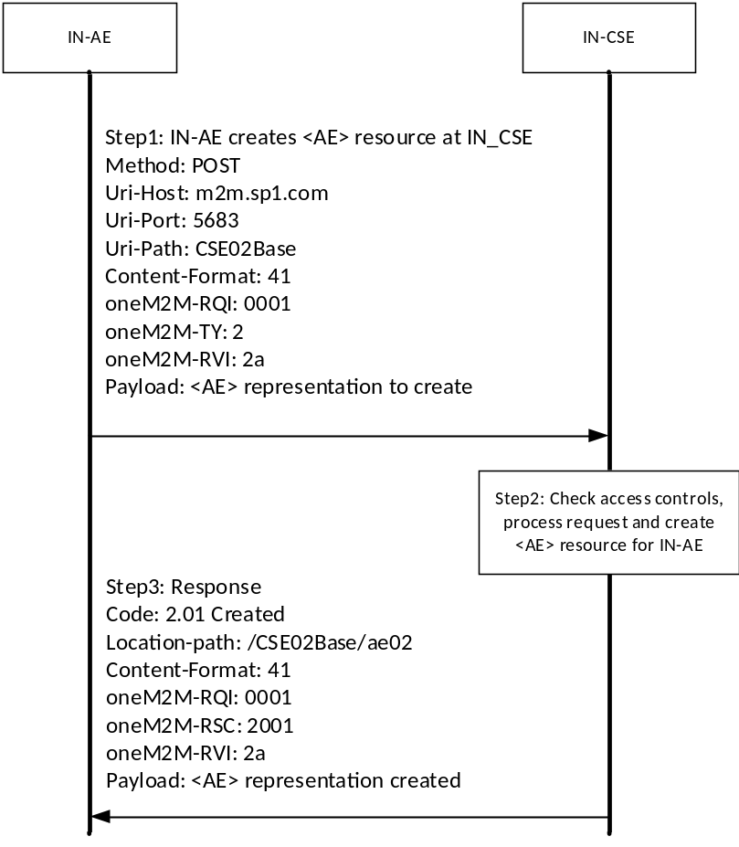
Figure A.1-1 Binding Example - Blocking case of AE Registration

A.2 Non-blocking synchronous case of AE Registration
Figure A.2-1 illustrates CoAP mapping of AE Registration procedure described in clauses 7.2.2.1, 7.4.6.2.2 and E.2 of oneM2M TS-0004 [2] and shows an example of non-blocking synchronous case which is described in clause 6.3.3.
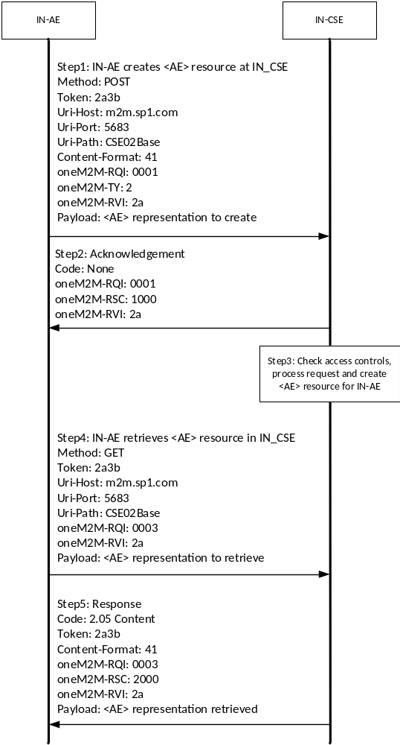
Figure A.2-1: Binding Example - Non-blocking synchronous case of AE Registration

History
Publication history
V1.0.1 | 30 Jan 2015 | Release 1 - Publication
V1.3.2 | 29 Feb 2016 | Updated Release 1 - Publication
V1.4.0 | 28 Jul 2016 | Incorporated CR:  PRO-2016-0331-new_RSC_mapping_in_TS-0008(R1)  Updated Release 1 - Publication

Draft history
V3.0.0 | 27 Feb 2018 | Release 3 - Generated out of 2.6.0  With incorporated CR:  PRO-2018-0019-TS-0008_RSC_mapping_for_multimediaSession  PRO-2018-0031-TS-0008-Response_Code_Mapping_for_localMulticastGroup

